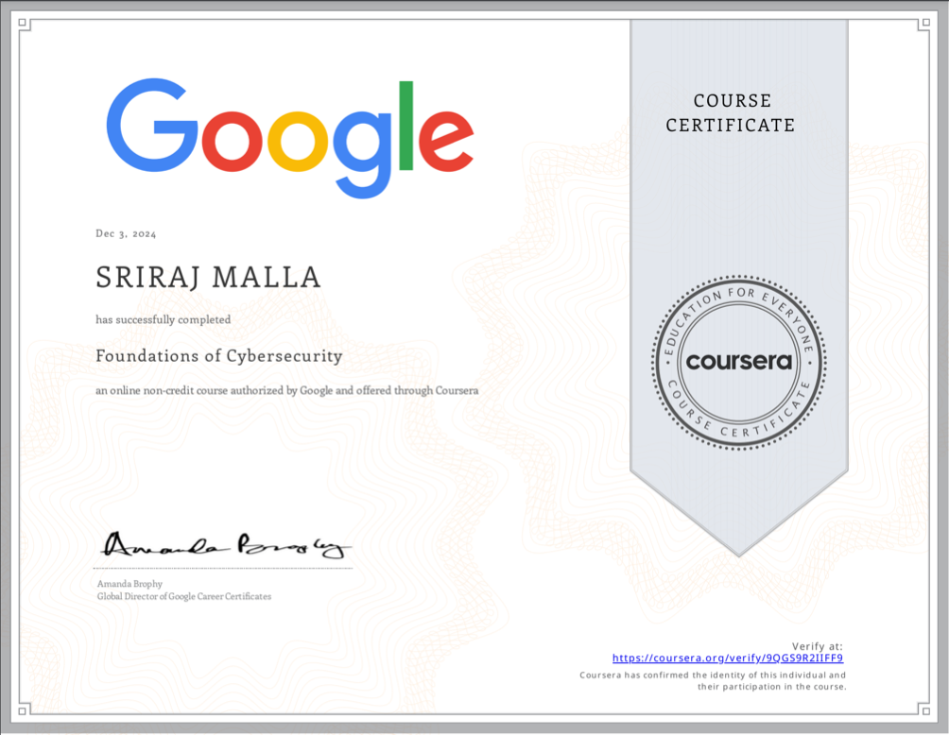

This is the first course in the Google Cybersecurity Certificate. These courses will equip you with the skills you need to prepare for an entry-level cybersecurity job. Below mentioned points are knowledge i gain in this first course

* + - * Identify how security attacks impact business operations.
      * Explore the job responsibilities and core skills of an entry-level cybersecurity analyst.
      * Recognize how past and present attacks on organizations led to the development of the cybersecurity field.
      * Learn the CISSP eight security domains.
      * Identify security domains, frameworks, and controls.
      * Explain security ethics.
      * Recognize common tools used by cybersecurity analysts.